CEG 4166 – Real-Time Systems Design
Laboratory 2: Controlling the Displacement of the Stingray Using a Distance Sensor for Obstacle Avoidance

Winter 2025
University of Ottawa
Faculty of Engineering, School of Electrical Engineering and Computer Science
Section 2
TAs: Devansh Kumar, Kamran Gholizadeh Hamlabadi

Group 9
Stingray 15
Team Members:
Keith Tran – 300240028 – ktran033@uottawa.ca
Kevin Dang – 300241133 – kdang038@uottawa.ca
Saurav Guduru – 300234999 – sgudu104@uottawa.ca
Submission Date: 2025-03-03
Table of Contents
Introduction 3
Objectives 3
Background Material 3
Functionality Scope 3
Theory 4
Real World Modelling 4
Control Principles 4
Programming Concepts 4
Experimental Setup 5
Hardware Architecture 5
Software Architecture 5
Testing Methodology 5
Results and Observation 6
Discussion 6
Challenges 6
Solutions 6
Results 7
Future Recommendations 7

Introduction

Objectives
The objectives of the laboratory are as follows:
- Implement pre-programmed paths for the robot to travel along
- Implement keyboard control, with functions mapped to specific keyboard inputs
- Implement a sonar system that detects nearby obstacles
- Implement an obstacle avoidance algorithm that causes the robot to backtrack, sweep left and right, and reroutes the robot around the obstacle if an obstacle is detected

Background Material
This lab builds upon the previous lab, which aimed to set up the robot’s systems (e.g. internet connection, SSH connection, package installation) and writing a set of basic movements for the robot along with a graph plotter for plotting data about the robot’s movements. This lab expands greatly on the previous, adding whole paths for the robot to travel, as well as implementing sensory modules for obstacle detection and image capture. This lab also implements direct user control over the robot with the use of keyboard inputs.

Functionality Scope
The functionality to be implemented for this lab are as follows:
Camera: the camera module captures live imagery, which is displayed on the terminal
Pre-programmed paths: the robot independently travels along two distinct programmed paths
Sonar control: the robot is able to rotate the sonar at any angle within a 180-degree range
Obstacle detection: the robot can detect nearby objects using sonar sensors
Collision avoidance: once an obstacle is detected, the robot backtracks and performs a sonar sweep, from which it will decide which direction it will continue forward to avoid collision
Direct user control: the robot’s movement can be controlled via keyboard inputs

Theory

Real World Modelling
In this lab, real world modelling was performed to simulate the physical behaviour of the stingray robot. The stingray was modeled using differential equations that describe its response to control signals. In addition, this lab models the stingray's response to pulse width modulation (PWM) signals which allowed us to control the speed of the DC motors.

Control Principles
The control principles used in this lab mainly consisted of the PID (Proportional Integral Derivative) controller to regulate the robot’s movements. By using a PID controller, it ensured that the robot would move in our desired path by minimizing the error between the theoretical and actual wheel speeds. Additionally, the lab required us to implement an obstacle avoidance algorithm and sonar which required precise control of the speed to ensure that the stingray would properly follow its path after detecting and avoiding an obstacle.

Programming Concepts
The following are the important programming concepts used in this lab.
Multithreading and concurrency: the different functions of the robot were executed on separate threads that ran concurrently.
Object-oriented programming: subsystems of the robot (e.g. wheel movement, sensor, camera) were virtualized as objects in the code, each with their own attributes and functions and instantiated in one shared main running program.
Use of packages: python packages were imported to make use of external tools and libraries in our code. Packages were included to plot graphs, implement multithreading, and interact with the Raspberry Pi’s GPIO interface.
Responding to user input: the robot’s program implemented direct user control over the robot’s functionality via keyboard.

Experimental Setup

Hardware Architecture
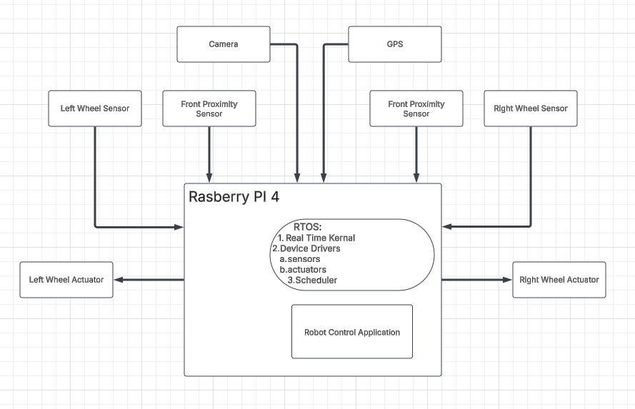

Software Architecture
The software architecture is comprised of the following program modules:
- KeyboardGPIO.py: defines the keyboard controls, with mapping of keys to specific functions of the robot
- PID.py: a virtualization of the PID controller
- PlotDataRobot.py: plots the data concerning the robot’s movement on a graph
- WheelEncoderGPIO.py: defines the encoding for the wheel servos
- CameraGPIO.py: defines the camera component of the robot
- UltrasonicGPIO.py: defines the graphical user interface displayed on the robot
- Lab2.py: the main method of the software; combines all individual modules into one cohesive running program

Testing Methodology
Our methodology for testing was to first test individual components of the program at a time, then gradually test components together, before testing all the components running under one program. This was done by commenting out atomic modules of the code that were not immediately related to the specific function currently being tested.
When calibrating the servos, a trial-and-error approach was exercised. For the wheels, the preprogrammed path would be run, and the precise movements of the robot were observed. Whenever the robot deviated off the expected path even slightly, the program was halted and adjustments were made to the values of the signal strength sent to the servos, or the amount of time each servo would run for given a specific movement command (e.g. amount of time the robot spent turning determined the angle it would proceed at). A similar process was adopted for fine-tuning the sonar sensor; we ran many trials until the precise values for the servo were identified.

Results and Observation
No performance data was recorded for this lab.
The source code for this lab can be found zipped in the file titled the following: “CEG4166_2025W_Section2_Group9_Lab2_Code_20250303-01.zip.”

Discussion

Challenges
In this lab, we encountered many challenges while trying to implement the various features on the Stingray robot, one of them concerning the robot itself. Our specific robot had power issues, with the battery not charging effectively when plugged in, which caused the robot to shut down spontaneously due to power shortage, and during times in which it did have power, it did not have enough to sufficiently supply the various actuators of the system, most importantly the servos. This meant that the servos would not move accurate to the commands given to the robot by the written program, with the robot not turning by a large enough degree or veering off to one side when meant to travel in a straight line.
Another issue we faced was implementing all the software modules cohesively. Each component of the software architecture was developed individually to divide the workload efficiently among team members, however there was a lack of communication or coordination amongst the team during the development process. Hence, when trying to integrate all the components into one system, incompatibilities arose that required time and effort to identify and resolve.

Solutions
A solution for the battery issue was simply switching to a different robot. Switching to a robot with a more effective battery system resolved the issues that its predecessor faced. The only caveat was that the program was adjusted to accommodate the specific qualities of the previous robot and thus had to be readjusted to be compatible with the replacement. Through trial-and-error, we were able to find the desired values for servo movement, running each moving component individually to identify which ones needed to be accounted for in the code adjustments, and to what degree.
For the compatibility issue, we were able to resolve the various issues by working together. Many of the problems arose how to implement the different threads all running concurrently, each running a different functionality component of the robot. By working together, we were able to combine our knowledge and experience with each of the individual components to create a system with all components working harmoniously.

Results
Overall, the results obtained were very close to the results that were expected. The robot was able to perform all the functions specified by the lab manual, however these functions could not fully be demonstrated simultaneously. For instance, while the sonar operated while the robot moved along its preprogrammed path, its avoidance function was not fully effective; the robot would resume moving on its path before the avoidance algorithm finished executing, invalidating its avoidance path calculation as its sweep was not performed in a static location. The path itself was also close to, but did not exactly match, the expected path, as the robot’s movement was slightly off from what it was programmed to do.

Future Recommendations
If this lab was performed again in the future, there are some improvements we would recommend for an improved result and more efficient development process.
Firstly, we would implement a way for threads to sleep and wake up. This way, critical functions performed by one thread would not be interrupted by the execution by another thread. For instance, the avoidance function performed by the sensor thread was interrupted by the path function of the movement thread. By putting all other threads to sleep until it was finished executing, the robot would stay in place while it performed its sweep when running the avoidance algorithm.
Secondly, we would work more closely as a team, ensuring that we communicate more with each other and inform one another about developments concerning each of our individual tasks. That way, each member of the team is informed on every aspect of the lab, smoothening out potential compatibility issues.

